**1.0 Overview**

This project intends to deliver a system that will provide the hospital staff with software that will be capable of updating and retrieving the current location of a medical record with the use of a laser scanner as well as the ability to input basic patient information that is common among various departments as well as information specific to certain departments with a minimum amount of keyboard entry and no redundant data entry. The system will also provide search capability to identify information about a patient and their medical record using the name of the patient or other criteria if necessary. The system will also be capable of generating reports that provide the government with statistical data relating to hospital operations. The hospital can benefit from an increase in operational efficiency, which will allow hospital staff to focus more on the care of patients and less on the manual work involved in keeping physical logbooks. Patients can expect a much better experience from reduced wait times and the elimination of the need to walk across the hospital complex to complete administrative tasks.

**2.0 Customer Statement of Requirements**

**2.1 User Requirements:**

**UR1.** A staff member creates a patient record.

**UR2.** A staff member checks out a patient record to a specific location.

**UR3**. A staff member checks in a patient record to a specific location.

**UR4**. A staff member searches for a patient record.

**UR5**. A staff member checks a patient into the NICU.

**UR6**. A staff member checks a patient out of the NICU.

**UR6**. A staff member checks a patient into the ER.

**UR7**. A staff member checks a patient out of the ER.

**UR8**. A staff member checks an inpatient in.

**UR9**. A staff member checks an inpatient out.

**UR10**. A staff member checks an outpatient in.

**UR11**. A staff member checks an outpatient out.

**UR12**. A staff member merges two patient records.

**UR13**. A staff member prints reports.

**3.0 Glossary of Terms**

.Net: a set of programming languages

AIDS: Autoimmune Deficiency Syndrome, a disease of the human immune system

ASP.NET: a programming language

C#: a programming language

ColdFusion: a programming language

CS3750, CS4750: Computer science class in which we work on this project

CSS: a programming language for page layout in HTML

Database: A software system for efficient data management on a computer

Electronic form: a series of fields displayed on the screen for user input

Field: a section of the electronic form for entering data by typing or selecting

HTML: a programming language for designing web pages

Java: a programming language

JavaScript: a programming language

jQuery: a programming language

N-Tier: A system for developing software that divides up the aspects of the system among: data access, server processing, and presentation

NICU: Neonatal Intensive Care Unit, the hospital ward where infants with serious illness are treated

Oracle: A database structure

Perl: a programming language

PHP: a programming language

RAPIDS: Record And Patient Identification Data System, the computer software and database structure that MedSoft is delivering to the Korle-Bu Hospital

Server: a computer that stores data and performs computing over a networked connection

Sickle Cell: an abnormal red blood cell having an elongated, crescent like shape due to the presence of abnormal hemoglobin.

Software: computer programs that perform a specific function

SQL: a programming language for database

System: see RAPIDS

UML: universal modeling language, a collection of diagrams that permit specific description of a software system to improve communication among stakeholders

Web page: A web page or webpage is a document or resource of information that is suitable for the World Wide Web and can be accessed through a web browser and displayed on a monitor or mobile device.

Website: A group of web pages stored on a common server with a common purpose

**4.0 Functional / Non-Functional Requirements**

**4.1 Stakeholders:**

Professor Rich Fry – Project Sponsor

Korle Bu CEO – Project Client

Peter Litster, Austyn Mahoney, Jared Plumb, Brian Sneddon, Jacob Troxel – Project Team

**4.2 Actors and Goals:**

Staff

* Generic term for personnel employed by the hospital

Administrator

* Staff having direct interest in the contents of a report

Accounting

* Staff involved in the handling of accounts

Functionality

* The system will be capable of retrieving data via laser scanner
* Access to personal data will be limited to authorized personnel via system enforced permissions
* The system will be capable of storing limited patient data
* The system will be capable of providing the physical location of a medical record

Usability

* The system will provide a simple user interface that is consistent with users with little to no prior computer use
* The system will provide a detailed user manual that outlines step by step how to accomplish the main functions of the system
* The system will use ample white space to support an aesthetic that is compatible with the simple user interface

Reliability

* The system will require routine database backup for recovery in case of a server failure

Performance

* The system will be able to respond to user action within 5 seconds for all tasks
* The system will require 95% availability
* The system will require less than 2 hours recovery time
* The system will require less than 100GB hard drive storage

Supportability

* The system architecture will support extensibility for future versions, the database can be expanded as well as user interface and server side code can be reused
* The system will require minimal server configuration and administration
* The system will be localized to the hospital complex

Design Constraint

* The system design is constrained by the lack of computer experience of the users, functionality must be extremely simplified, direct, and efficient
* Unknown and diverse use of client hardware requires the use of an internet browser for the user interface to eliminate the problems associated with installing a client application on each machine

Implementation Requirement

* Implementation languages required are HTML and JavaScript, PHP or ASP.NET may be used for sever side operations. An open source database technology is preferred

Interface Requirement

Physical Requirement

* The system requires client machines with modern Windows or Linux based operating systems capable of running modern internet browsers. The client machines must be networked and capable of TCP/IP data transfer with a web server.

**5.0 Use Cases**

*GUC01 - Search Patient Records*

The staff member receives any or all of patient name, address, date of birth, or patient id. Then they enter patient data as search criteria into the system to attempt to locate the patient in the system.

*GUC02 - Scan barcode*

The staff member takes the physical medical record and uses the laser scanner to transfer the data contained in the barcode to the system so the location of the physical medical record can be updated.

*GUC03 - View patient record*

The staff member views a screen that has information about the patient in general as well as information that is relevant to a specific department of the hospital. The staff member will then be able to make decisions on how to proceed.

*GUC04 - Update patient record*

The staff member modifies existing patient data or adds new patient data to the system.

*GUC05 - Create Patient*

The staff member creates a new patient. If this is the Records Desk, a physical record is created and a Patient ID is assigned.

*GUC06 - View patient visits*

The staff member views a screen that provides a list of previous and current visits for a given patient.

*GUC07 - Generate report*

The staff member generates a report that can be related to general hospital operations or that is specific to a certain department.

*GUC08 - Record Payment.*

Staff or accounting personnel record payment for hospital visit.

*NICU01 - Admit Patient*

Collect and enter information about a child checking into the Newborn Intensive Care Unit.

*NICU02 - Discharge Patient*

Patient is checking out of the hospital.

*HUC01 - Admit Patient*

Additional information is added to patient record for admission to hospital ward.

*HUC02 - Discharge Patient*

Patient is checking out of the hospital.

**6.0 Detailed Use Cases**

|  |  |
| --- | --- |
| **Identifier** | GUC01 |
| **Name** | Search Patient Records |
| **Description** | The staff member receives any or all of patient name, address, date of birth, or patient id. Then they enter patient data as search criteria into the system to attempt to locate the patient in the system. |
| **Actor(s)** | *Staff* |
| **Preconditions** | N/A |
| **Post Conditions** | The system will provide the user with zero to many results based on the search criteria |
| **Assumptions** | The user will be provided patient data that the system can use as search criteria. |
| **Normal Flow** | 1. Staff member enters search criteria into system. 2. Staff member is returned a set of results based on search criteria. 3. Staff member identifies the correct result from the result set. |
| **Alternate Flow** | 2a. There are no results after the search the staff member executes the patient creation use case. |

|  |  |
| --- | --- |
| **Identifier** | GUC02 |
| **Name** | Scan barcode |
| **Description** | The staff member takes the physical medical record and uses the laser scanner to transfer the data contained in the barcode to the system so the location of the physical medical record can be updated. |
| **Actor(s)** | *Staff* |
| **Preconditions** | N/A |
| **Post Conditions** | The location of the physical medical record is updated and available for all users. |
| **Assumptions** | Laser scanner is operational, the physical medical record is in hand, and the barcode label is not damaged. |
| **Normal Flow** | 1. Staff member initiates update record location in the system. 2. Staff member scans the barcode with the laser scanner and the data is sent to the system. |
| **Alternate Flow** | 2a. The data is not sent to the system due to an error with the laser scanner or the barcode is damaged. The staff member troubleshoots the laser scanner by trying to scan in another record. If that is successful the barcode on the original record is replaced. If more than one barcode can not be scanned in the laser scanner is replaced. |

|  |  |
| --- | --- |
| **Identifier** | GUC03 |
| **Name** | View patient record |
| **Description** | The staff member views a screen that has information about the patient in general as well as information that is relevant to a specific department of the hospital. The staff member will then be able to make decisions on how to proceed. |
| **Actor(s)** | *Staff* |
| **Preconditions** | N/A |
| **Post Conditions** | The staff member has the ability to make informed decisions about patient care. |
| **Assumptions** | N/A |
| **Normal Flow** | 1. Staff member executes the search patient records use case (GUC01). 2. Staff member selects view patient record. 3. Staff member views patient data based on permission level. |
| **Alternate Flow** | N/A |

|  |  |
| --- | --- |
| **Identifier** | GUC04 |
| **Name** | Update patient record |
| **Description** | The staff member modifies existing patient data or adds new patient data to the system. |
| **Actor(s)** | *Staff* |
| **Preconditions** | N/A |
| **Post Conditions** | The patient data in the system is up to date and available for users of the system. |
| **Assumptions** | N/A |
| **Normal Flow** | 1. Staff member executes the view patient record use case. 2. Staff member selects edit record and modifies or adds new patient data to the system. |
| **Alternate Flow** | N/A |

|  |  |
| --- | --- |
| **Identifier** | GUC05 |
| **Name** | Create Patient |
| **Description** | The staff member creates a new patient. If this is the Records Desk, a physical record is created and a Patient ID is assigned. |
| **Actor(s)** | *Staff* |
| **Preconditions** | A search has been performed to ensure the patient does not already have a record. |
| **Post Conditions** | The patient has a record in the system that may be linked with visit records. |
| **Assumptions** | N/A |
| **Normal Flow** | 1. Staff selects option to create a new patient 2. Staff enters patient’s name. 3. Staff enters patient’s date of birth. 4. Staff enters patient’s gender. 5. Staff enters patient’s address. 6. Staff marks checkbox for AIDS, cardiac, sickle cell, etc. if applicable. 7. Patient is referred to Patient Creation Desk for a physical record |
| **Alternate Flow** | 6a. This is the patient creation desk: staff obtains a new physical record for the patient and inputs the Patient ID Number.  7a. System prints a barcode label for the clerk to affix to the physical record. |

|  |  |
| --- | --- |
| **Identifier** | GUC06 |
| **Name** | View patient visits |
| **Description** | The staff member views a screen that provides a list of previous and current visits for a given patient. |
| **Actor(s)** | *Staff* |
| **Preconditions** | N/A |
| **Post Conditions** | The staff member can make informed decisions based on the history of visits for a given patient. |
| **Assumptions** | N/A |
| **Normal Flow** | 1. Staff member executes the view patient record use case. 2. Staff member selects view patient visit history option from the system. 3. Staff member makes decisions for patient care based on the history of the patient’s visits. |
| **Alternate Flow** | N/A |

|  |  |
| --- | --- |
| **Identifier** | GUC07 |
| **Name** | Generate report |
| **Description** | The staff member generates a report that can be related to general hospital operations or that is specific to a certain department. |
| **Actor(s)** | *Staff* |
| **Preconditions** | N/A |
| **Post Conditions** | Reports are available for hospital administration and government officials to review various aspects of hospital operations. |
| **Assumptions** | Data required to generate the report is stored in the system. |
| **Normal Flow** | 1. Staff member initiates report generation section of system. 2. Staff member selects from a list of reports that are available for generation based on the staff member’s privilege level. 3. Staff member views the report on screen and has the option to print a physical copy. |
| **Alternate Flow** | N/A |

|  |  |
| --- | --- |
| **Identifier** | GUC08 |
| **Name** | Record Payment. |
| **Description** | Staff or accounting personnel record payment for hospital visit. |
| **Actor(s)** | *Staff/Accounting* |
| **Preconditions** | Patient already has a record and has been admitted. |
| **Post Conditions** | Payment is recorded on patient’s record. |
| **Assumptions** | N/A |
| **Normal Flow** | 1. Staff looks up the patient record by Patient Number or name. 2. Staff records the amount billed. 3. Staff records the amount paid. 4. Staff records the receipt number. |
| **Alternate Flow** | N/A |

|  |  |
| --- | --- |
| **Identifier** | NICU01 |
| **Name** | Admit Patient |
| **Description** | Collect and enter information about a child checking into the Newborn Intensive Care Unit. |
| **Actor(s)** | *Staff* |
| **Preconditions** | N/A |
| **Post Conditions** | A log record has been created for the child, and linked to physical record. |
| **Assumptions** | The child was born at this hospital and already has a physical record. |
| **Normal Flow** | 1. Staff looks up patient record by Patient Number or name. 2. Staff records mother’s name (first, middle, last). 3. Staff records the patient’s birth weight in kilograms. 4. Staff records the patient’s time of birth. 5. Staff records the patient’s time of admission. 6. Staff records the patient’s referral (midwife, born in home, hospital). 7. Staff records the location of the patient’s mother in the hospital if applicable. 8. Staff records the patient’s maturity (gestation period in weeks). 9. Staff records the patient’s mode of delivery (SVD, breach, C-section) 10. Staff records the patient’s parity (number of previous miscarriages the mother had). 11. Staff records the mother’s age. 12. Staff records the cubical the patient is in. 13. Staff records the patient’s entry diagnosis. |
| **Alternate Flow** | Cause: The child does not have a physical record.  1a. Staff cannot find patient record when searching by Patient Number or name.  2a. Use Case GUC05  3a. Continue with step 2 of normal flow. |

|  |  |
| --- | --- |
| **Identifier** | NICU02 |
| **Name** | Discharge Patient |
| **Description** | Patient is checking out of the hospital. |
| **Actor(s)** | *Staff* |
| **Preconditions** | Patient has been checked in |
| **Post Conditions** | Patient discharge information is recorded. |
| **Assumptions** | Patient will check with Staff before leaving. |
| **Normal Flow** | 1. Staff looks up the patient record by Patient Number or name. 2. Staff records the patient’s final diagnosis. 3. Staff records the patient’s discharge weight. 4. Staff records the patient’s discharge date. 5. Staff records the patient’s special treatments list (bililights, etc). |
| **Alternate Flow** | N/A |

|  |  |
| --- | --- |
| **Identifier** | HUC01 |
| **Name** | Admit Patient |
| **Description** | Additional information is added to patient record for admission to hospital ward. |
| **Actor(s)** | *Inpatient Staff* |
| **Preconditions** | A patient record must exist. |
| **Post Conditions** | A record has been created that is associated with the patient’s main record. It contains data pertinent to inpatient records. |
| **Assumptions** | The patient already has a record created and will be admitted to one of the wards. |
| **Normal Flow** | 1. Staff searches for record by ID or patient name. 2. Staff selects Admit Patient option. 3. Staff selects patient’s Current Occupation. 4. Staff enters Principal Diagnosis. 5. Staff selects ward the patient will be admitted to. 6. Staff reviews summary view of patient information to insure correctness. 7. Staff submits form to admit patient or cancels process. |
| **Alternate Flow** | Cause: The patient does not have a record created   1. Staff cannot find patient record when searching by Patient Number or name. 2. Use Case GUC05 3. Continue with step 2 of normal flow. |

|  |  |
| --- | --- |
| **Identifier** | HUC02 |
| **Name** | Discharge Patient |
| **Description** | Patient is checking out of the hospital. |
| **Actor(s)** | *Staff* |
| **Preconditions** | Patient has been admitted to the hospital and has a patient record. |
| **Post Conditions** | Patient discharge information is recorded. |
| **Assumptions** | Patient will have paid any fees. |
| **Normal Flow** | 1. Staff selects patient from currently admitted list. 2. Staff updates any diagnosis. 3. Staff updates any treatments necessary. 4. Staff checks summary screen to insure all patient data is correct and makes any necessary updates. 5. Staff submits discharge form or cancels. |
| **Alternate Flow** | N/A |

**7.0 Use Case Diagrams**

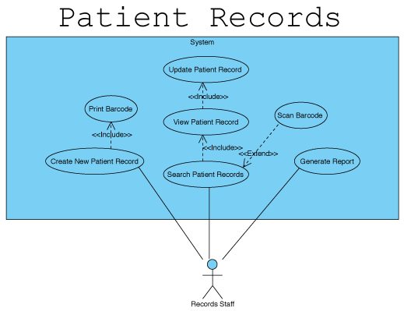

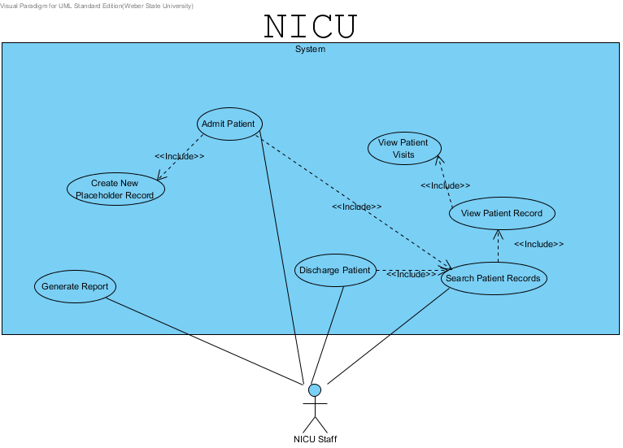

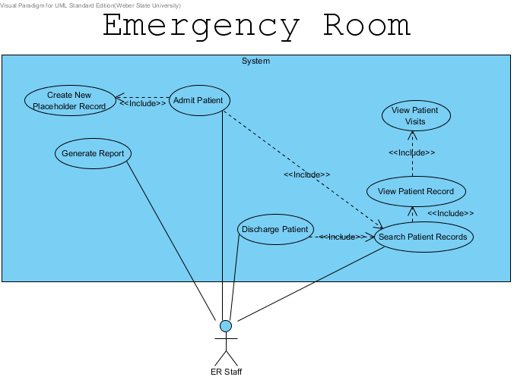

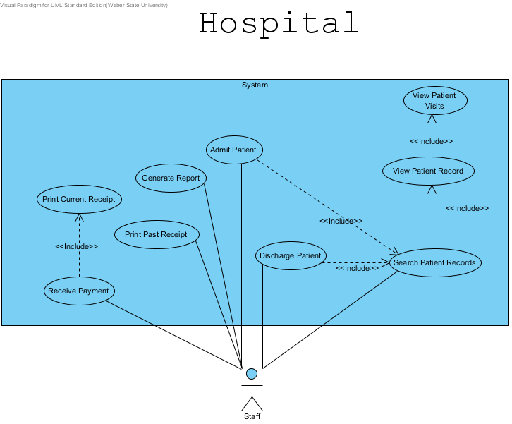

**8.0 Sequence Diagrams**

GUC01

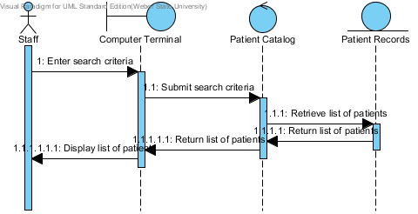

GUC02

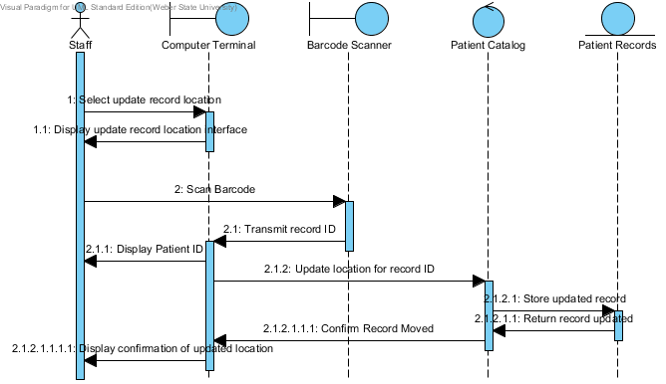

GUC03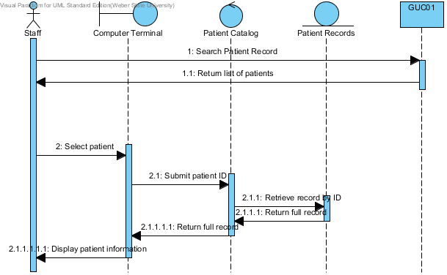

GUC04

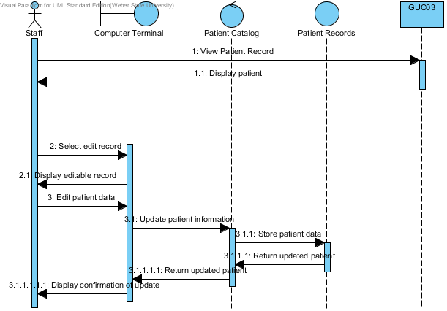

**9.0 Activity Diagrams**

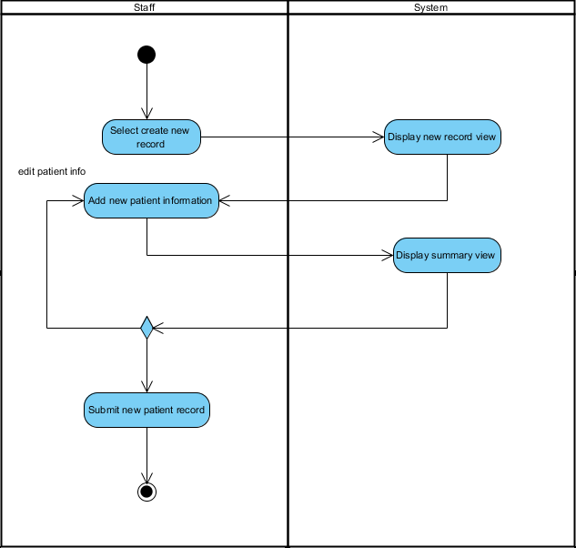

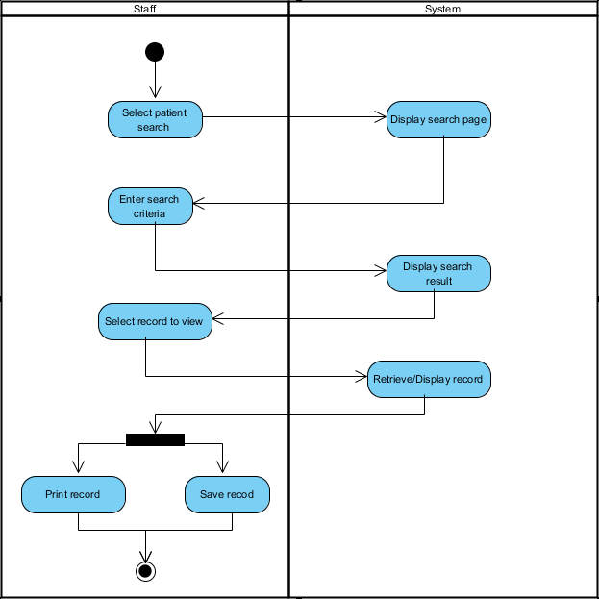

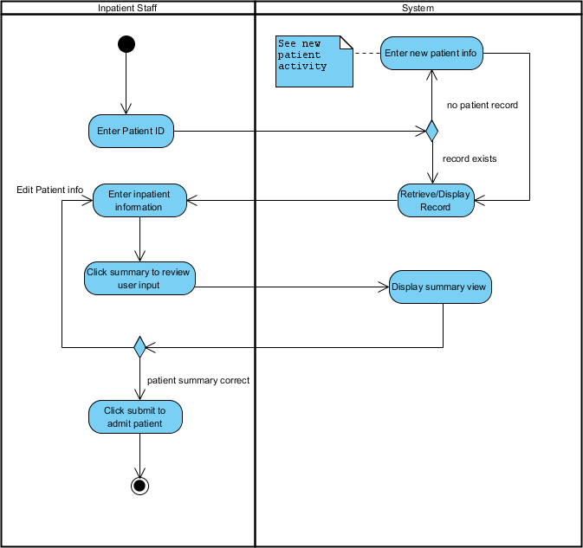

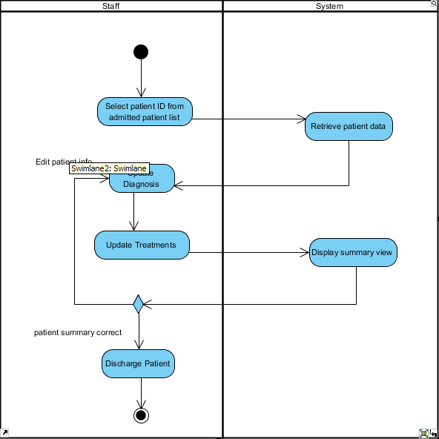

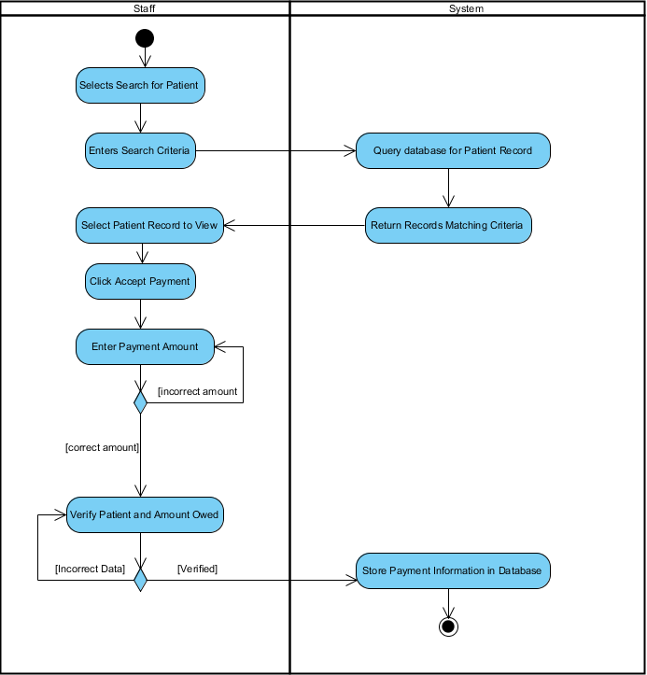

**10.0 User Interface Mockups**

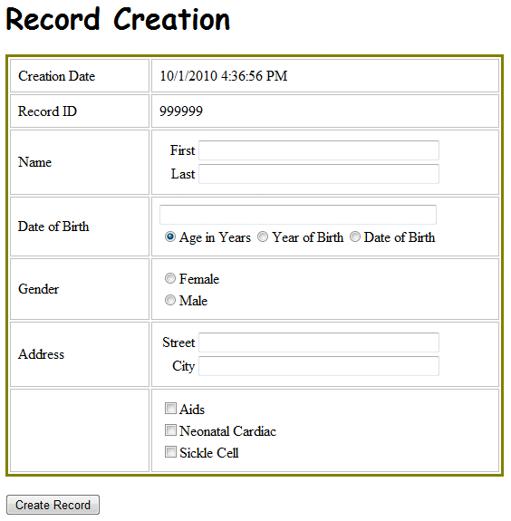

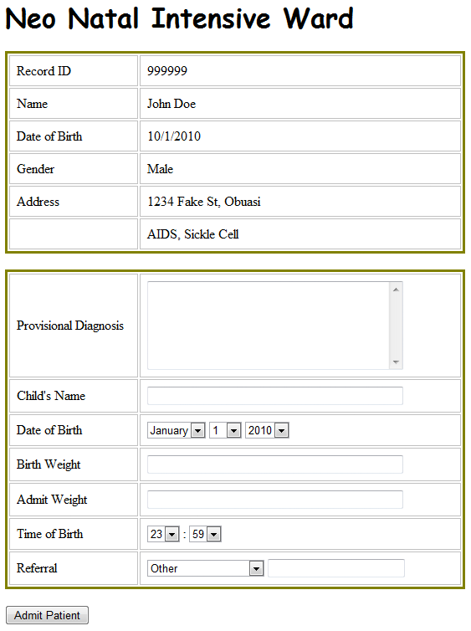

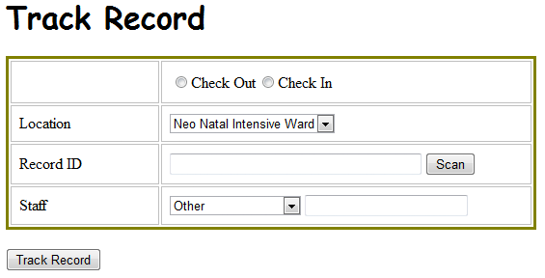

**11.0 ERD**

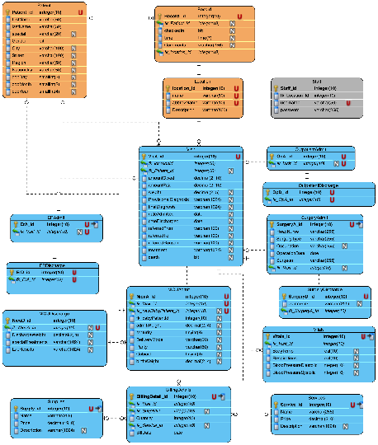**12.0 Version History**

*October 2, 2010* – Initial Draft

*October 5, 2010* – Removed unneeded terms from Section 3.0. Corrected Numbering and Format in Section 6.0. Added actors to Section 4.2. Peter Litster

*October 10, 2010* – Alphabetized the glossary, updated header and footer – Jared Plumb

*October 11, 2010* – Removed unnecessary sections, updated page numbering, and updated the table of contents – Jared Plumb

*December 1, 2010* – Updated several sections slightly. Added the final ERD – Jared Plumb